**GDD – Pockey**

Have you ever been at an arcade and couldn’t decide between playing pool or air hockey? Well, neither have we - but it only makes sense to combine these two beloved games to make an incredibly fun and addicting experience. Pockey is a 1v1 online pool game that is playable on PC or mobile via internet browser, allowing you to compete against friends or strangers in this original twist on the classic 8-ball pool game. Whether you’re looking to kill some time or reach the highest ranks of the leaderboard, Pockey is the perfect casual meets hardcore game.

**Features**

* **Rank system**

[DESCRIPTION]

* **Weekend tournaments**

[DESCRIPTION]

* **All-time leaderboard**

Players who are into the more competitive feel can try and use the All-Stars leaderboard. This leaderboard ranks the top 10 in the entire game based on points, allowing the users to show off their skills!

* **Cosmetic goodies**

[DESCRIPTION]

* **Cross-platform**

Pockey started as a browser based game but instantly we knew we wanted it to be playable to all our future players whether mobile or computer. We didn’t want to make pockey an application for mobile players so instead we made it accessible via the internet browser and just scaled it differently so everyone could be able to enjoy the game.

* **Achievements**

[DESCRIPTION]

* **Bet against opponents**

[DESCRIPTION]

* **Player profile, level-ups, and more!**

[DESCRIPTION]

**Gameplay**

**Core**

The core gameplay is quite simple, two players face each other in a game of pool with a twist: it’s also air hockey. At the game start, the balls are placed in a pre-defined pattern with 7 colored balls for each player. To shoot, players hold down LMB and move their cursor to aim but also to change the shot’s power, and then releasing the LMB key fires the shot. Players will have only 20 seconds to shoot or their turn is over. Each player has 7 health points and whenever a ball of theirs is sunk they lose 1 health. Scoring the puck removes 2 health points. Each match is composed of a best of 3 round system.

**Normal Mode**

Normal mode is the standard gameplay mode where you queue up with whoever is closest to you in points at the current time. When you win a match you gain points to get closer to your next rank. As a player gains more and more points it allows them to get closer and closer to the leaderboard or if they already are on the leaderboard, it will help them get higher. When players go against other players they end up gaining points based on the rank each player is. When playing against a guest the point system is ignored and is just a plus twenty or minus twenty.  
  
Once you finish a match you have the choice of fighting the player again (Rematch), or choosing to fight against a new opponent.

~~Normal mode is the standard gameplay mode where you queue up with whoever is available and then you start. However, if you win a match, the next player you face will have won their previous match as well. This creates a natural difficulty curve as you climb a dynamic ‘ladder’ facing tougher and tougher players. For every consecutive match you win against a player you receive bonus Rank Points. Once you lose your score is tallied and added to your Win Streak stat located on the Main Menu - this stat is also what defines the All-star Leaderboard.~~

~~One caveat to normal mode is that sometimes servers might reach a low pop which would make it harder to find other winning players to queue with. If the server can’t find any other winners to match you with, you will get matched with any random player that’s in queue while still maintaining your win streak. In addition, you can hit “Replay Opponent” after a match is over and play that person repeatedly, but this does not affect your win streak.~~

**~~Weekend Warrior Mode~~** ~~(post-launch)~~

~~During the weekends we have a special automated event using the Normal Mode mechanics. Basically starting on Saturday morning (9 AM PST) the game will start storing every player’s win streaks thats separate from the normal leaderboard data. Players will play the game as normal with the goal of trying to have the biggest win streak until the tournament ends on Sunday night (11:59 PM PST).~~

~~The top ten players will win 5 crate boxes and keys but the top 3 will get (in addition) a Master crate / key, which offers a guaranteed exclusive item skin as well as 2 other random legendary items.~~

~~Visually there won’t be much added to illustrate there is a tournament going on but players will notice a couple new elements: on the main menu there will be a ‘tournament is live’ graphic near the Play button, and in-game you will see your placement in the tournament. It would be also very cool if you could “spectate” the top players in the tournament if they’re online.~~

**Gameplay Extended**

In addition to the core gameplay, there are some ideas I think could benefit the overall gameplay and give it more of a unique vibe.

**~~Goalie~~**

~~When it's not your turn to shoot balls, you play as a goaltender. You can control a small ‘wedge’ that moves up and down very slowly in front your goal. This can block not just pucks but also balls.~~

**~~Power-ups~~**

~~Every turn a new power-up icon spawns above one of the 6 table holes. If you sink any ball into the hole with a power-up, you will earn that power-up (i.e. gain 1 health point).~~

**Penalty shot**

If a player scratches on the white ball, his or her opponent can place the white ball wherever he/she decides to place it within reason. If the player sinks the puck in its goal the same concept is in place, the opponent gets to place the puck.

**~~Match Betting~~**

~~You can checkmark a box that lets you queue up for games with bets. Players will bet with Starcade currency at a flat rate of X per match. At the end of the game, both players can agree to a rematch for double the currency.~~

**~~Custom matches~~**

~~Allow players to make private matches with a few setting options such as shotclock, rounds per match, etc. Custom games do not affect rank points or win streaks.~~

**More Ideas**

* ~~Spectate - View top players or friends as they play against opponents~~
* ~~English - Allow players to click an area on a circle sprite that changes ball trajectory~~
* ~~Party mode - If you’re in a party and choose party mode, you can all play together in a round-robin king-of-the-hill type of game mode where you try to win as many consecutive matches in a row, when you lose you wait in line to play again.~~

**Item Shop**

**Item Crate & Keys**

Cosmetic item skins are obtained, like all other Starcade games, through Item Crates. The first crate (presumably available either at launch or shortly thereafter) will contain a finite amount of skins and be obtainable for free but once we have a safe and secure account/inventory system in place we will offer the first crate and all future crates at a price.

To obtain a crate for free, you simply have to play the game. For example, every time you level up your account you will get a Skeleton Crate which can be used to open up any Starcade game crate. However, you can get Pockey crates directly from playing the game and doing a variety of activities:

* At the end of every match 5% chance to drop a Pockey crate
  + This percentage increases by 1 for every consecutive win, up to 10% droprate
* After unlocking achievement completeness 25% / 50% / 75% / 100%
* Complete specific (difficult) achievements
* Get top 10 in a ‘Pockey Weekend Warriors Tournament’
* Increase your Rank and Level (mystery box)

**Item Skins** (percentages are per crate drop rates)

Every crate you open will give you 3 items. Typically you will get 1-2 poolsticks and a ball decal. But sometimes you’ll get a new color or a new table decal. Very rarely you’ll unlock a new goal box or table.

* Poolsticks 125% - 1 to 2 poolsticks per crate (common to legendary)
* Ball decals 75% - 1 ball per crate (common to epic)
* Color 30% - 0-1 bonus color per crate (rare to epic)
* Table Decal 20% - 0-1 table decal (rare to legendary)
* Goal box 10% - 0-1 goal box (epic to legendary)
* Table 5% - 0-1 table skin per crate (legendary)

**Item Rarity** (numbers listed are estimates)

* Common 95%
* Uncommon 75%
* Rare 32%
* Epic 16%
* Legendary 8%
* Unique 100% (gifted by a developer or from a special promotion/event)

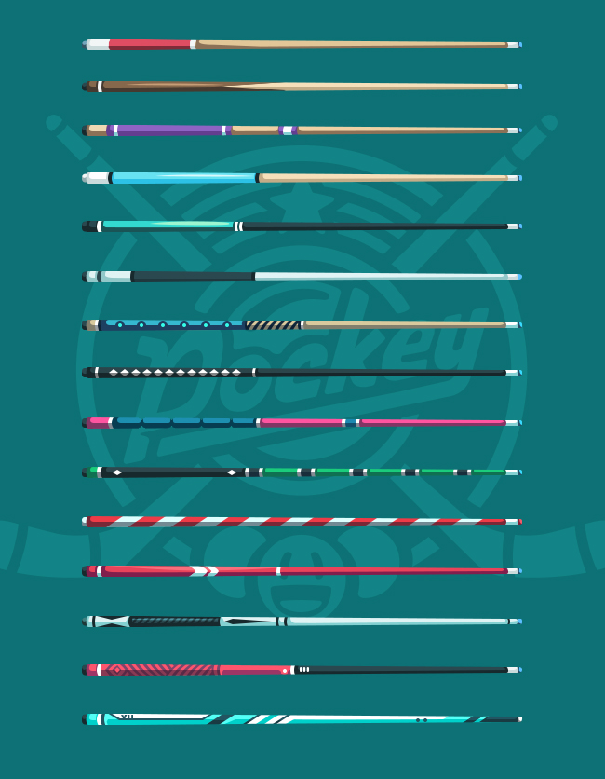

**Animations**

**Shooting**

The shooting is really just one animation sequence created in Spine using an FFD mesh that has its vertices weighted to two bones. In addition, there's a shadow slot which is used to create depth depending on the player’s shot intensity and a highlight slot to help illustrate the angle.



Most importantly, the animation sequence runs for 30 frames. At frame zero the stick is in its default pose and at frame 30 the stick is at its highest peak/most powerful. When the player holds down LMB and moves their cursor the stick will scrub from frame 0 to frame 30 where frame 30 is max distance from the scratch ball. Releasing the LMB shoots the ball - which is essentially just the same animation but in reverse and faster. Afterwards the stick disappears and its the other player’s turn. Some notes:

* ‘**root**’ in the animation rig should rotate around the scratch ball
* I’ve included an animation ‘**shot-reverse**’ if we can’t reverse animation procedurally
* We need to confirm if the **tinting** feature in spine renders correctly in-game
* When you hit LMB, the aim reticule should be locked onto the ball, to change the aim, players can move the stick back to frame zero position and release LMB
* FFD Meshes *cant use the Skin slot attachment*, but it appears I can duplicate the mesh inside the slot and apply a different weapon skin - we need to test if this method works and if so, I can add all the poolstick skins into one Spine file export.



These are of course only prototype rigs and animations, the rig/workflow would be identical in the final version but have much more polished structure and convincing motion.

**Balls**

The ball will have its own rig system as well. Essentially we have our main ball sprite, a shading overlay, and most importantly a decal sprite (item shop). We don’t actually have to make things this complex - this is just our best visual option.

So the key element here is the decal sprite, this is rendered on a Spine2D FFD mesh hand-shaped like a sphere’s wireframe. The mesh deforms as it rotates thus creating an illusion of a 3D rolling ball - enhanced by a semi-transparent shading sprite. To make this possible, we have to use a clipping mask tool with Spine which uses CPU to process and may be expensive so we’ll need to test this. In addition, we have to test to see if the tint/shading works as well - since supposedly it doesnt work with canvas as a renderer but it does work with WebGL.

   

* Use ‘**controller-ball**’ or ‘**root**’ to move the ball
* Use ‘**controller-rotation**’ to rotate the decal
* Use ‘**controller-lighting**’’ to rotate lighting

We can completely ignore this complex ball workflow and just have a basic sprite for the ball too. I don’t really care much for putting too much effort into the ball and this setup might be too complex/expensive - the pool stick sequence I think is the most important. This was just an idea I had that I was hoping could be a solution to having convincing ball rotation but also get another item shop revenue source. If we go with this method, I’ll polish up all the assets once we see the flaws in-game.

**Rank System**

A brand new player will start the game with 0 rank points. From there each player will gain points from wins against opponents, those points will be based on the rank of both the player and the opponent. Ex: Same rank gets +40 -40

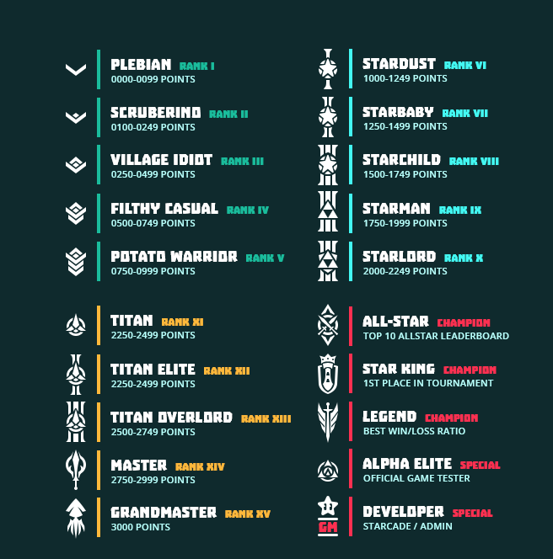

In order to reward players and provide incentive for ranking up, players receive new sticks to show off their new rank.

**Game Rules**

A player must win at least 2 of 3 rounds. The first player to lose all of their health points (balls) loses the round. You can score the puck once per round for 2 health points.

* **Core**
  + **1. Shot Clock -** Players are given 20 (?) seconds to shoot per shot, if they have not taken their turn within the shot clock time-frame, the player’s turn is forfeited
  + **1. Scoring** - Whenever a ball goes in a hole, whether accidental or not, 1 health point is removed from the respective ball owner’s health.
  + **2. Score-streak** - Players can shoot multiple shots as long as each shot results in scoring a ball in
  + **4. Own goal -** Accidentally shooting your own ball in will end your turn
  + **5. Breaking -** The first player (a) turn to break is randomly decided when game starts. The other player (b) will get to shoot first/break on the second round. If a third round occurs, the first player (a) to shoot will shoot first again. Players will alternate breaking on each subsequent game.
  + **6. Color-sharing -** If two players share the same color selection, the player’s opponent will ‘appear’ to have a different color on their screen
* **Scratching**
  + **7. Scratching -** A player scratches on the white ball if the white ball makes it into one of the holes. The player who scratched loses their turn and the other player can now place the white ball anywhere within the table.
  + **7b Scratching ext -** If we want to make this rule realistic and increase game difficulty - then if the white ball doesn't hit a ball or the boundary during a turn then it would be a scratch as well.
* **Puck**
  + **8. Puck scoring** - Scoring the puck in your opponent’s goal will remove 2 health points from them
  + **9. Penalty major** - Shooting the puck in your own goal will forfeit your turn and your opponent gets to place it wherever within the field

**Audio**

Here are some potential audio files we can use. We may want to use more than one for the same file for variation - especially with soundtracks.

**Core**

Pack: <https://audiojungle.net/item/billiard-sports-sfx-pack/6135319>

Pack2: <https://audiojungle.net/item/billiards/4066031>

Pack3: <https://audiojungle.net/item/billards-pack/20445808?s_rank=9>

Ball hit: <https://audiojungle.net/item/ball-hits-ball/9644085?s_rank=73>

Stick hit: <https://audiojungle.net/item/billiards-miscue-/13396120?s_rank=17>

Game start rack: <https://audiojungle.net/item/billiards-shuffle-rack/13396042?s_rank=36>

Bumper hit (requires simple edit/cut): <https://audiojungle.net/item/billiards-shot-rebound-off-bumper-into-other-balls/13210938?s_rank=12>

Ball sink/hit/double hit: <https://audiojungle.net/item/billiards/4066031?s_rank=10>

Goal

**UI Packs**

<https://audiojungle.net/item/game-interface-and-achievement-pack/11280171>

<https://audiojungle.net/item/game-interface-and-achievement-pack-2/12660471>

<https://audiojungle.net/item/game-interface-and-achievement-pack-3/13789319>

<https://audiojungle.net/item/retro-gaming-pack/20099366>

<https://audiojungle.net/item/interface-pack/20122946>

<https://audiojungle.net/item/interface-pack/16153120>

**Soundtrack Loops**

Game: <https://audiojungle.net/item/trip-hop-loop/8526197>

Game/Queue: <https://audiojungle.net/item/chilling-out-at-the-electro-lounge-loop/7644243>

<https://audiojungle.net/item/chillout-hip-hop-loop/58961>

Mainmenu/Queue: <https://audiojungle.net/item/80s-loop/10684274>

End game/Scorescreen: <https://audiojungle.net/item/chiptune-arcade-game/16009871>

**Roadmap**

***Milestone 1 – Day 1 Design***

*Export core images needed for a prototype, flesh out the game design document.*

**Milestone 2 – Prototype**

We should aim to get the core mechanic prototyped: shooting (reusable for a golf game!). This will involve you being able to aim around your ‘scratch ball’ (white) in 360 degrees. Moreover, you can adjust the distance of your pool stick to the scratch ball which will dynamically change the power/force in which you hit it. We don’t need win conditions at this point, just the ability to shoot balls into pockets.

**Milestone 3a – Art Production**

**Pool table**

The pool table in the mock-up will be re-designed and polished a little but more importantly will be designed in a way that we can easily change the felt color (currently green) as well as border decorations – essentially the pool table can become item shop gear.

***Balls***

*The current balls are going to look pretty unrealistic when moving, we need to come up with a way to make them look better when they’re in motion. The puck will also see some improvements but also we can make variations for this as well.*

**Effects**: wind gush, impact sparks, puck score celebration, health depletion, ball score

**Milestone 3b – Gameplay Production**

**Ball collision and physics**

Refine the prototype until the ball and puck collision/physics are perfect.

**Online mode/turn-based gameplay**

Allow players to take turns shooting the ball

**Health depletion and win condition**

If a ball of your color gets sunk into a pocket, you lose one health. For pucks you lose 2 health. If you score your own color ball into a pocket on accident, you still lose 1 health. A full match is best out of 3 rounds. At this point we have a real game!

**Ranking**

Assuming we have account systems in place, we start granting ranks to the players. This will be displayed as an icon next to their player name.

**User-interface & HUD**

Integrate the main menu UI, game and app logo and HUD:

· Opponent avatar / name / rank

· Shot clock – players are given X seconds to shoot before their turn is surrendered

· Chat box (not available on mobile)

· Menu dropdown: sound/music icon, login/register button, inventory/skins, achievements

**Skins**

We’ll make a bunch of poolstick variations, maybe 1-2 free pool table themes, and a 5-6 free unlockable colors (default is red or blue). Aside from the table, balls, goalbox, and poolsticks, we can have different floor patterns that are randomly selected on game load – or perhaps the floor can match the player’s table skin?

**Milestone 4 – Post-production**

**Invite Feature**

While at the Main Menu, you can select the Invite Friends button which will create a pop-up showing a link. You can send this to anyone on any device and if they click it, they will be automatically placed into your ‘party’. If you hit play, you’ll both enter 1v1. If you invite more than 1 friend, one of three things can happen: be a spectator, convert the game mode to single-elimination per round + spectate when you're not playing, or perhaps the user will just get a message saying “Your friend started playing without you! What a dick!”

**~~Power-ups~~**

~~Look into the idea of power-ups. I’m certain I have no idea what these would be other than regenerate health (which could affect overall gameplay due to the finite amount of balls and of course increase match length which means less ad-rev)~~

**Account system**

This will probably require its own document for planning, but we should get the account system working properly at this point so we can list top ranks, achievements, and skins.

**Mobile support**

Since this game is turn-based, we should be able to optimize it for mobile users without them needing to download anything. All we need to do is trim/crop the unnecessary UI and replace it with something more compact (i.e. no avatar, just small text and a much thinner health bar)

**Achievements (could be moved to post-launch)**

Players who are logged into Starcade can unlock not just skins, but achievements too– we’ll make a few dozen of these and create special achievement icons/badges for overall game completeness (50% achievements unlocked = some special badge on your profile). Unregistered users will see these pop-up but with a bonus link to create a new tab to register a starcade account.

**Advertisement setup**

Get the advertisements displaying and working properly

**Achievements**

* **Faceoff King** - Score a ball on the face off 100 times
  + Reward: **X Starcoin X EXP**
* **Goldie** - Block 2 goals in one match
  + Reward: **X Starcoin X EXP**
* **5 Hole** - Score all the pucks in a match
  + Reward: **X Starcoin X EXP**
* **Five Hole** - Score all the pucks in a match
  + Reward: **X Starcoin X EXP**
* **Hat Trick** - Win 3 matches in a row
  + Reward: **X Starcoin X EXP**
* **PENTAKILL!** - Win 5 matches in a row
  + Reward: **X Starcoin X EXP**
* **Double Digits** - Win 10 matches in a row
  + Reward: **X Starcoin X EXP**
* **Godlike** - Win 15 matches in a row
  + Reward: **X Starcoin X EXP 1 Skeleton Crate**
* **Captain Collector** - Unlock half of Pockey’s available items
  + Reward: **X Starcoin X EXP 1 Skeleton Crate**
* **Hodor, Hoarder** - Unlock all of Pockey’s available items
  + Reward: **X Starcoin X EXP 1 Skieleton Crate**

**Statistics**

**Match Statistics**

* Ballstreak - displays how many balls you made in one during during a match
* Banksy - display any balls you made that were banked off a wall
* Trickshot - displays any trickshots (2 or more balls) you made in one shot
* Foul - displays the number of penalties you performed in a match
* Accuracy - represents you successful shot percentage
* Sniper - displays how many long distance shots you made without hitting a wall
* Puckluck - hit the puck with the cue ball and score any opponent balls

**Global Statistics**

* Win / loss - displays your win/loss ratio
* Winstreak – displays your highest number of matches won in a row
* Aces – displays how many times you’ve aced an opponent (7 or more points in one turn)
* Pockey – displays number of matches where you scored both pucks on your opponent
* Breaker - displays opponent balls you sank from the break
* Playtime – displays your overall playtime
* Shot-time Avg – displays average time spent taking a shot
* Match-time Avg – displays average length of player’s match

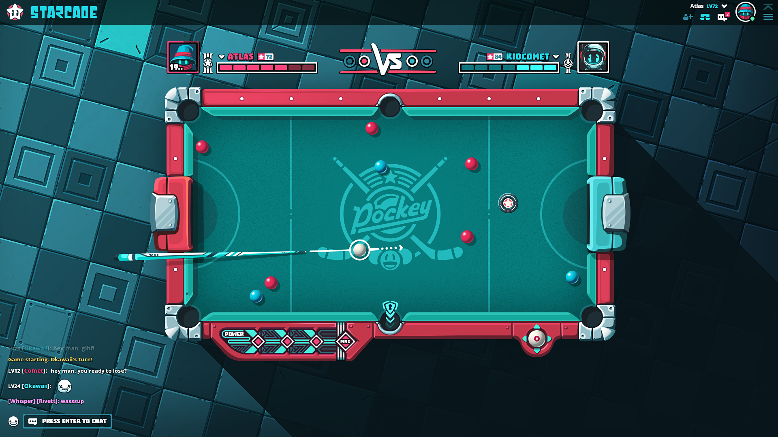

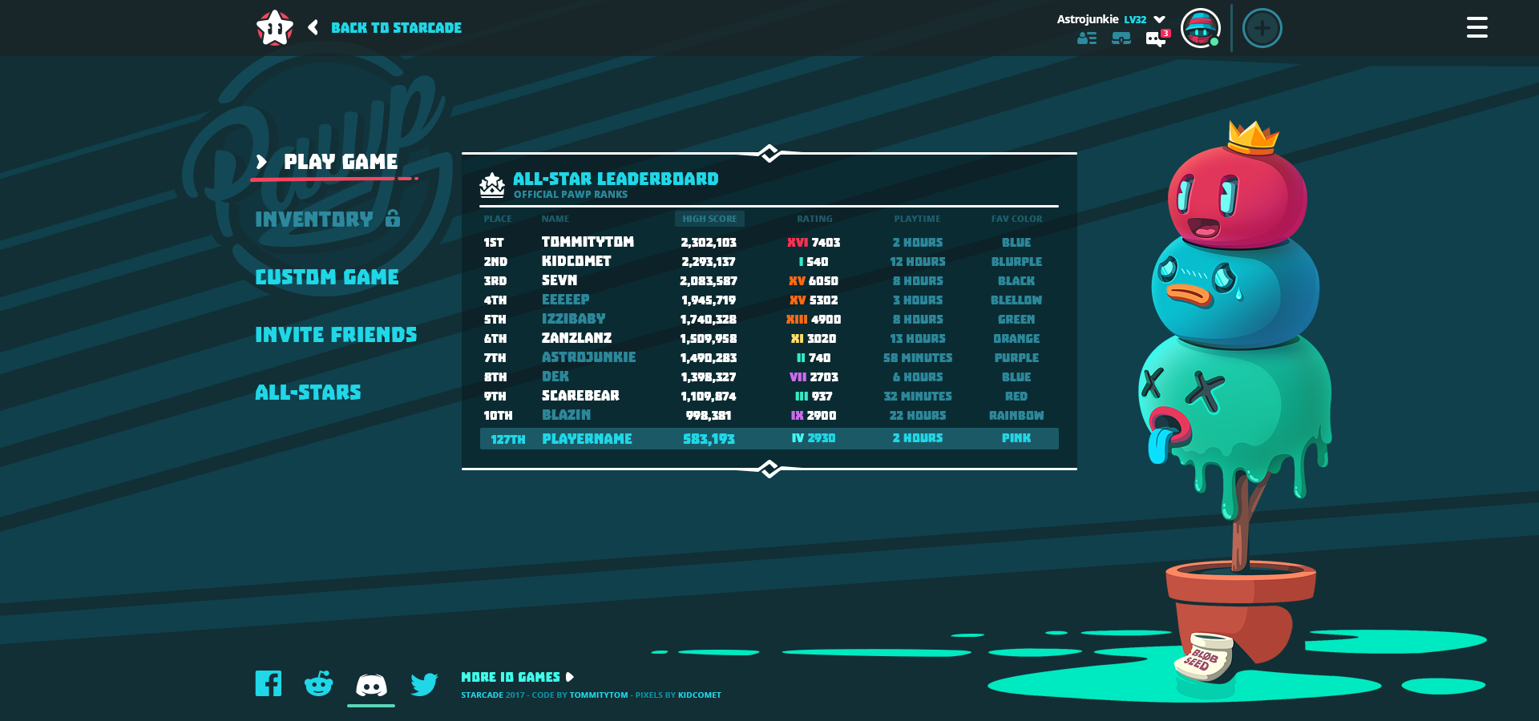

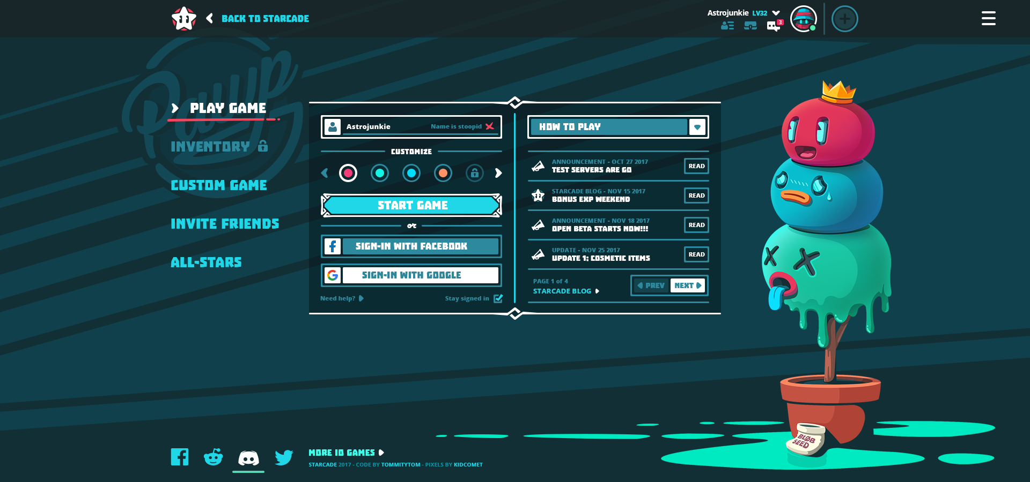

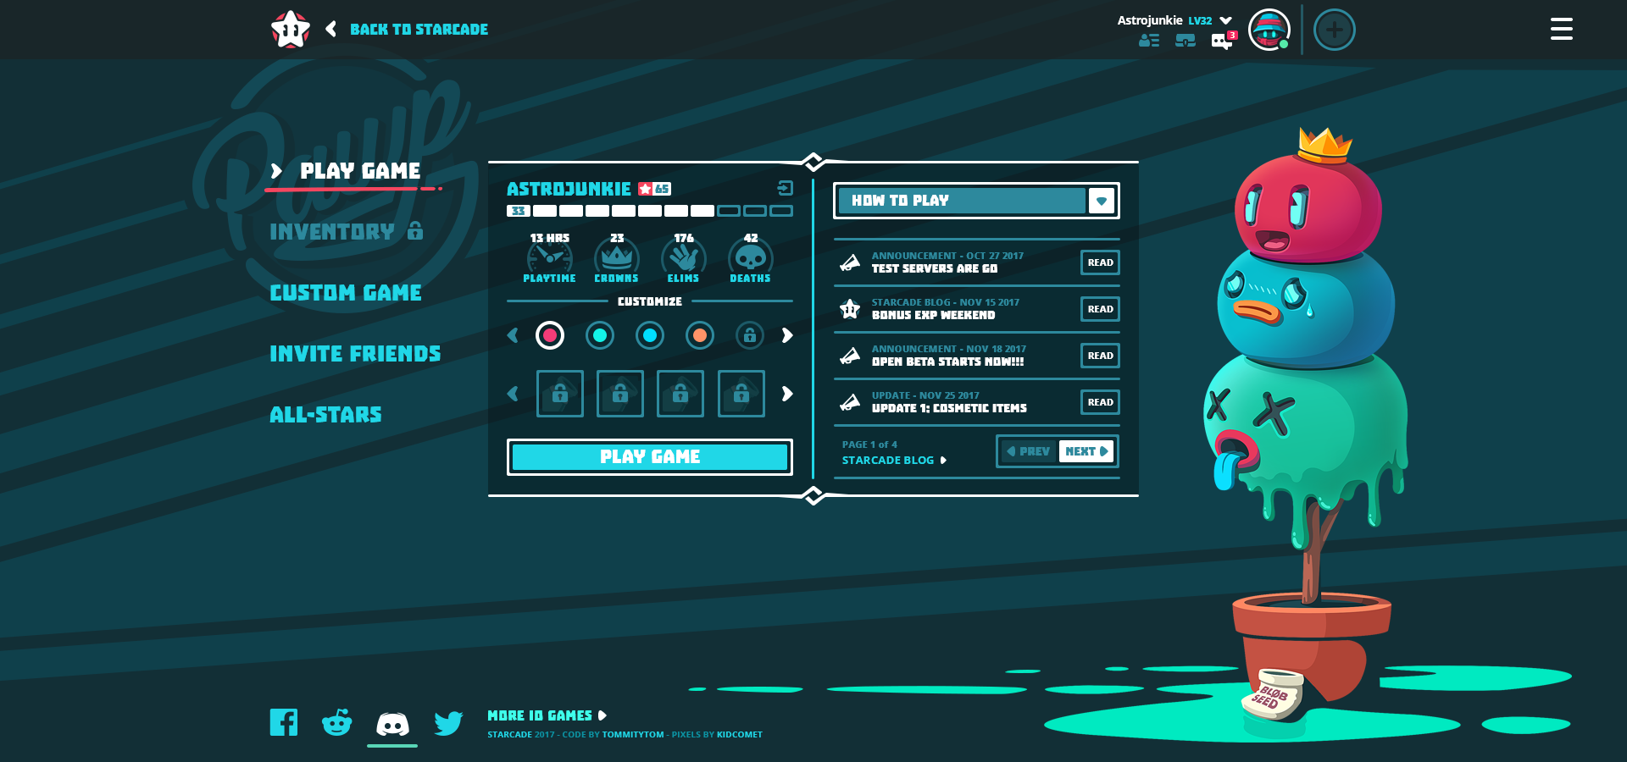

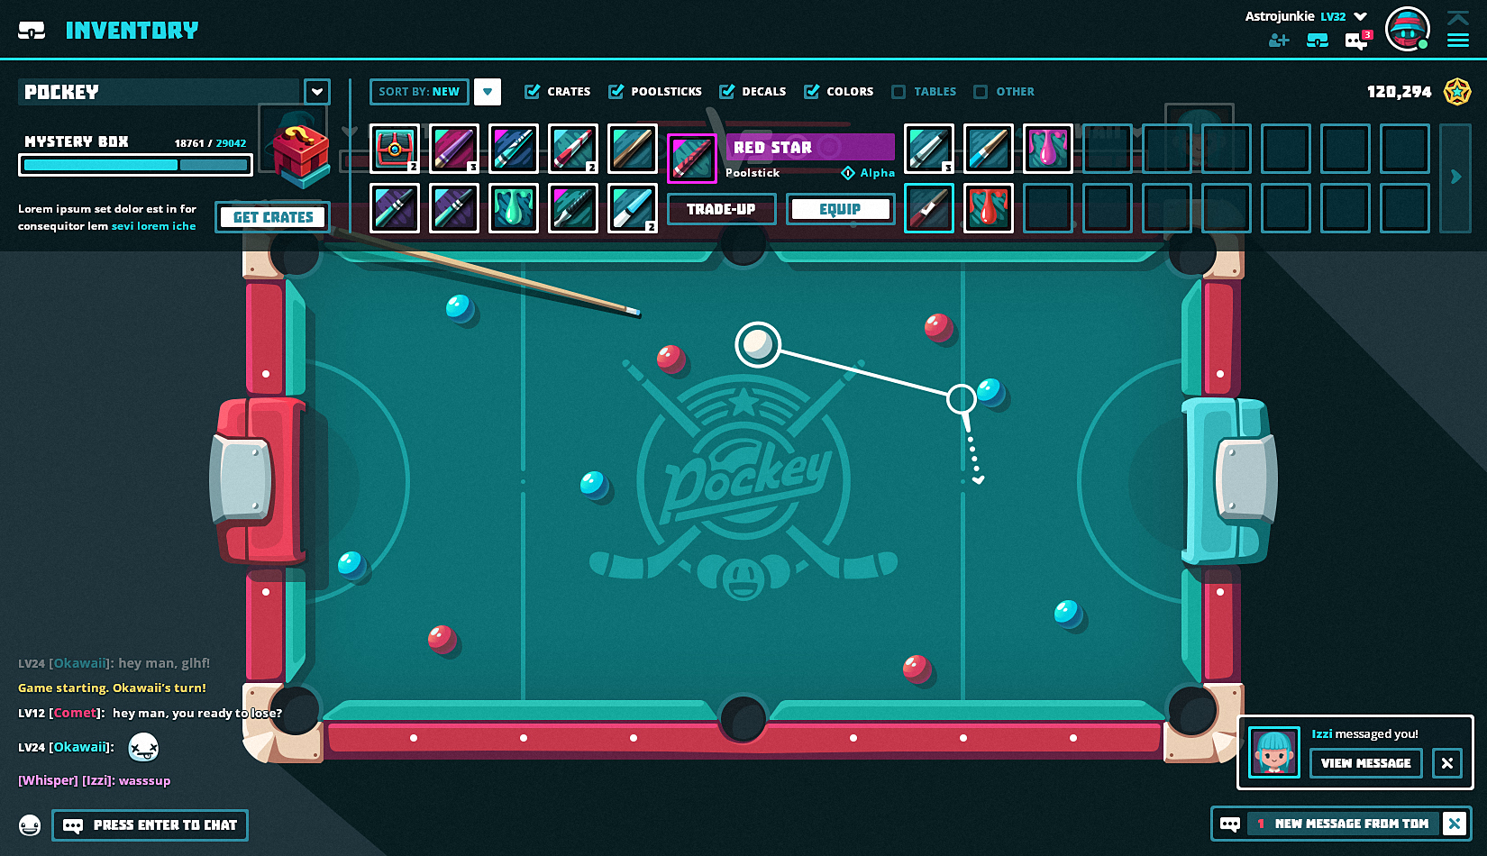

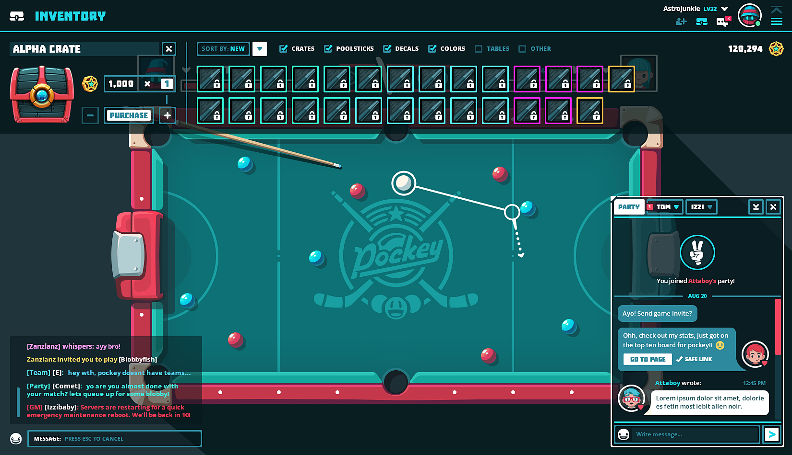

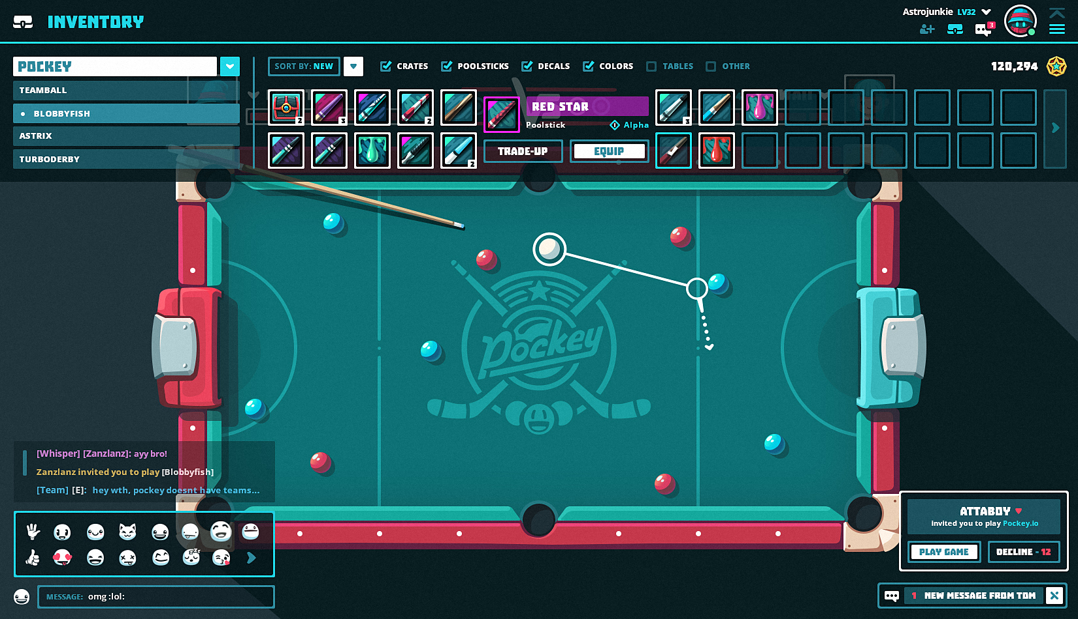

**Promo Codes usage**

Promo Codes can be used in the inventory screen to receive certain items as a gift. Promo codes consist of a code and a list of items the specific code will give. A promo can contain multiple items,too. To access and modify current promos, an admin can give commands in the chat window.

**List all promos:**

**!promos**

Example:

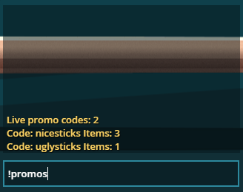

**Inspect a specific promo:**

**!promo <code>**

Items will be listed like:

Type id

Example:

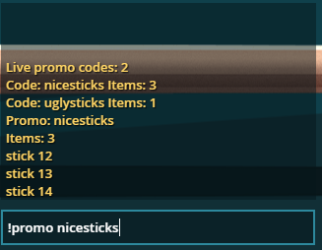

This promo contains sticks with id 12, 13, 14.

**Add item to a promo:**

**!promo <code> <type> <id>**

Example:

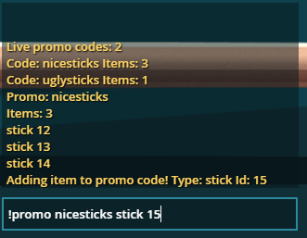

This will add a stick to nicesticks promo code, now it will give 4 items when entered.

**Note:**

If the promo code is not existing yet, a new promo will be **created** with the given item!

**Remove an item from a promo**

**!promo <code> delete <type> <id>**

Example:

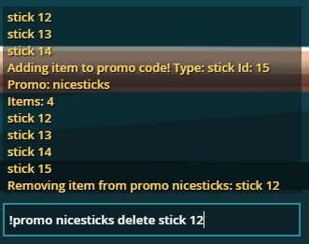

This will remove stick 12 from promo nicesticks

**Completely remove a promo:**

**!promo <code> delete**

Example:

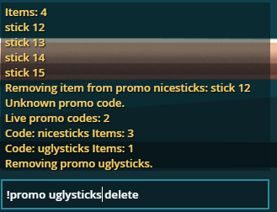

This will finally delete a promo code with all the items list. Items will be kept in user’s inventory, though.

Item with their ids can be found here:

<https://docs.google.com/spreadsheets/d/1zvcH0yVdxeHDIQ8gn9_6ANqWnddgNunimybA-3aljxU/>

Table Felt dimensions: width: 1016

Tabe: width: 1112 x height: 626

**DIALOGUES**

***[PLAYERNAME]*** *and* ***[YOU]*** *should be colored to match player color selection*

***First-game State: shooting (optional, but might be too difficult)***

*AIM WITH CURSOR, PRESS & HOLD [LMB BUTTON] AND DRAG TO SET POWER*

**First-game State: when its your turn to break - *(we need to tweak the break pattern)***

YOUR TURN TO SHOOT!

**Tip State: when a player’s turn starts**

YOUR TURN! SHOOT OPPONENT’S COLOR BALLS INTO POCKETS

**Tip State: when you *aim* at your own ball**

WARNING! HITTING YOUR OWN BALL FIRST IS A FOUL

**State: when you hit your own ball first**

[PLAYER NAME] FOULED!

**Tip State: when you aim at the puck**

*Result: goalbox of opponent has an arrow hovering of it + arrow indicator around puck*

SHOOT THE PUCK INTO [PLAYERNAMES] GOAL!

**State: when opponent fouls and**

[PLAYER NAME] FOULED! PLACE THE BALL ANYWHERE ON TABLE

**State: when players scratches on cue ball**

YOU FOULED! [PLAYERNAME] GETS BALL-IN-HAND

**State: when player scores his own ball in**

YOU FOULED! [PLAYERNAME]’s TURN!

**State: when you score puck in your goal**

PUCK WENT INTO YOUR OWN GOAL! [PLAYERNAME] GETS BALL-IN-HAND

**State: when you score the puck into opponent goal**

*Result:goal box flashes, some poppy sound is made and*

YOU SCORED THE PUCK! -2 HEALTH TO [PLAYERNAME]

**State: when you dont hit any balls**YOU DIDN’T HIT ANYTHING! [PLAYERNAME] GETS BALL-IN-HAND

**State: when you hit two or more balls in**

YOU MADE A TRICKSHOT! CONGRATS!

**State: when you hit the puck/other ball to make a different ball in**

YOU MADE A TRICKSHOT! CONGRATS!  
  
**Tip State: when an Pocket blocker icon appears**

POWER-UP AVAILABLE, SCORE A BALL IN THE POCKET ON FIRST SHOT

**State: when you shoot a ball into a Lock Icon pocket on your first shot of turn**

POWERUP! THIS POCKET WILL BE BLOCKED FOR YOUR OPPONENTS NEXT TURN

**State: when you score one of your balls in**  
[PLAYER NAME] POCKETED A BALL AND CAN SHOOT AGAIN!